Conclusion 12

Graph, Depth-First Search

1. Graph :

* Basics

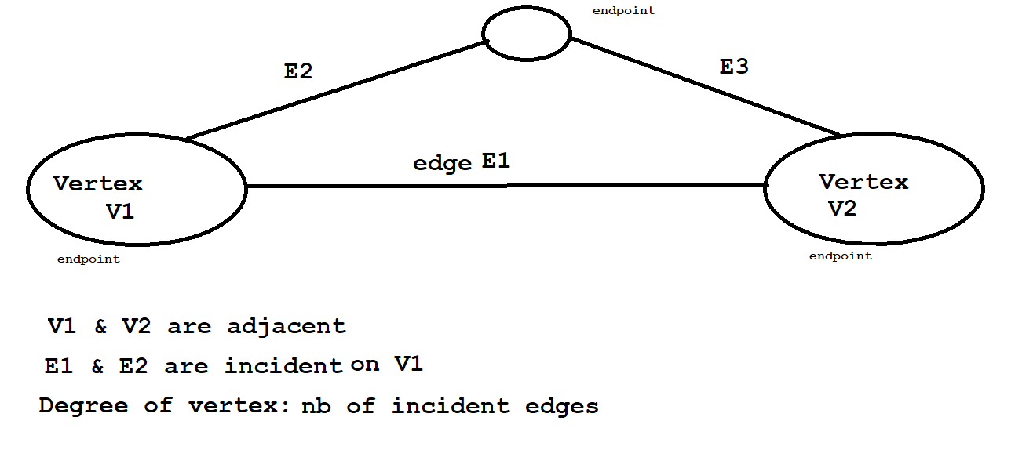

* Simple and not simple path (simple: all its vertices and edges are distinct)

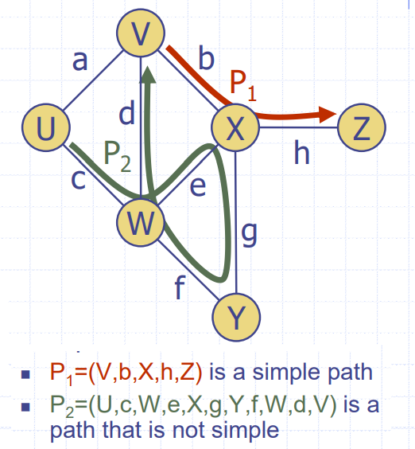

* Simple and not simple Cycle:

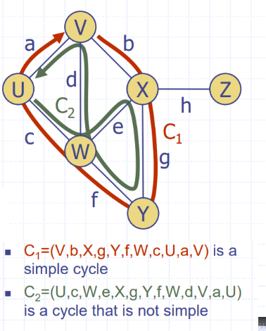

* A path in a graph is a sequence of alternating vertices and edges, starting with a vertex and ending with a vertex. A path is simple if all its vertices and edges are distinct.
* Properties

n number of vertices

m number of edges

deg(v) degree of vertex v

Σ deg(v) = 2m

m ≤ n (n − 1)/2 //direct graph = x2

spanning tree m=n-1 (connected no cycle)

not connected m=n-2 (can be cycle)

ADT

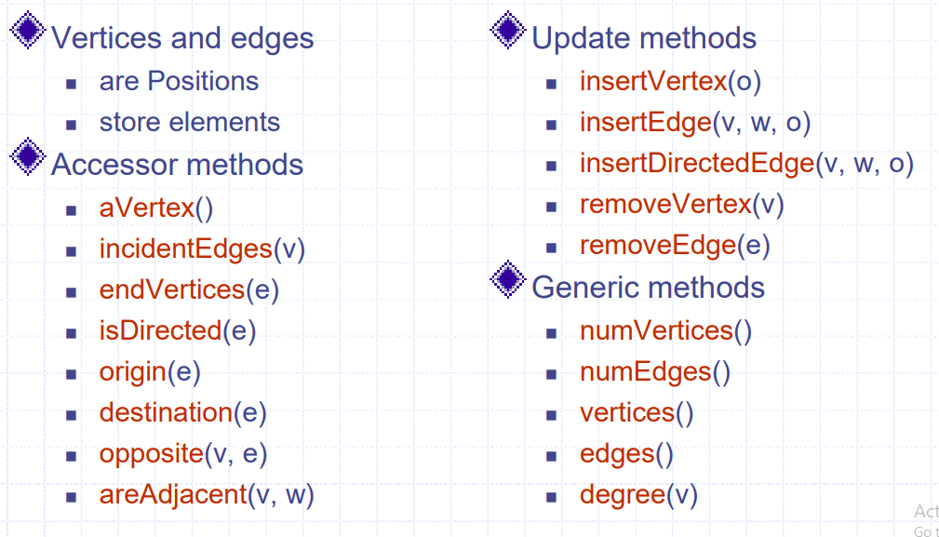

* Edge List Structure:

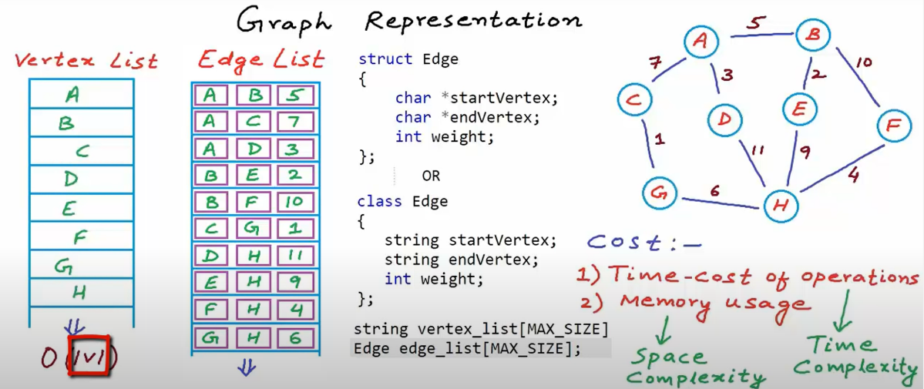

* Adjacency List Structure

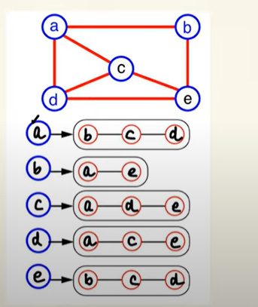

Adjacency List Structure:

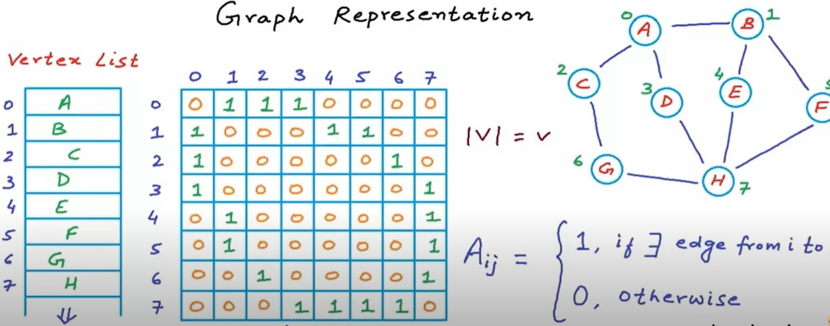

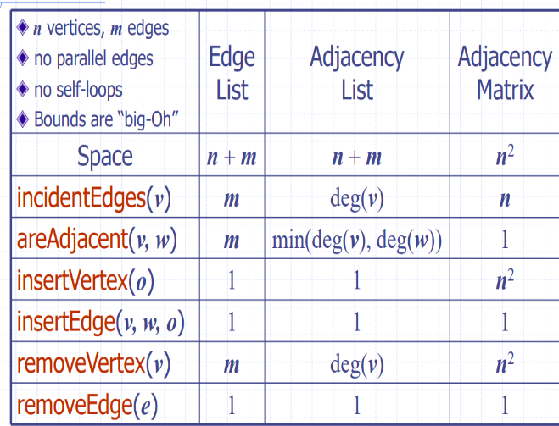 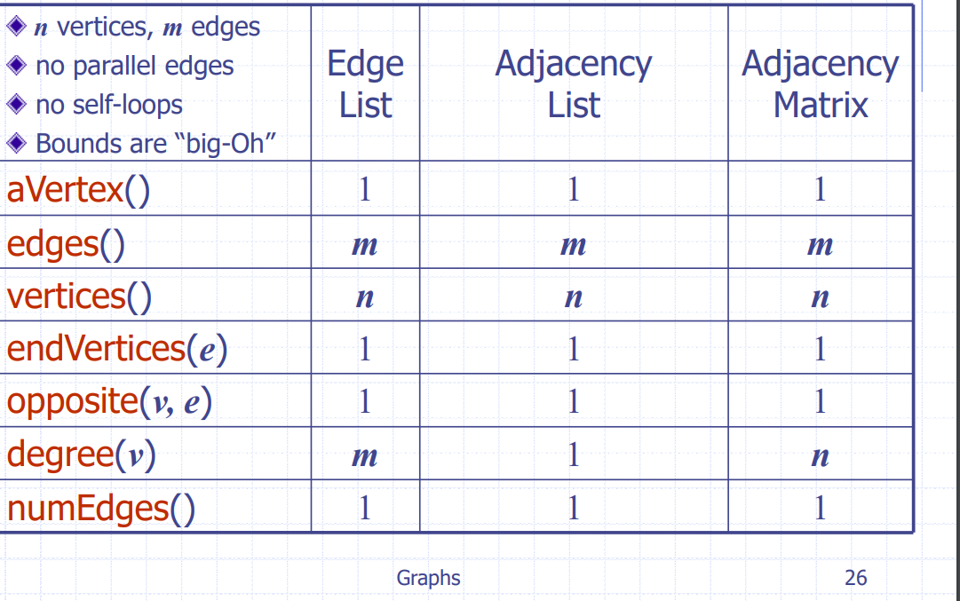

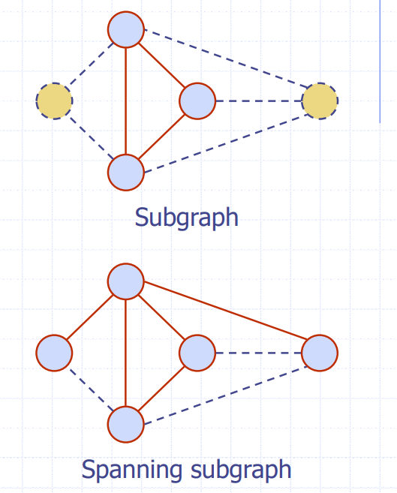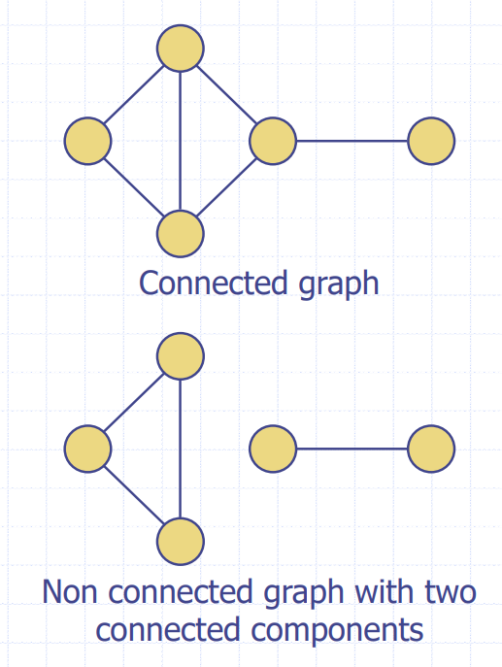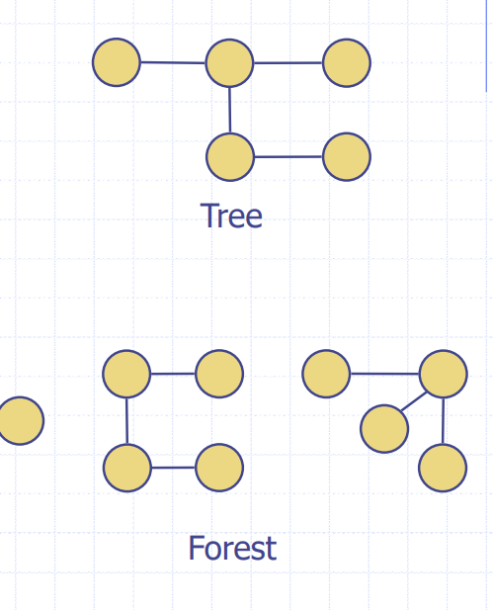

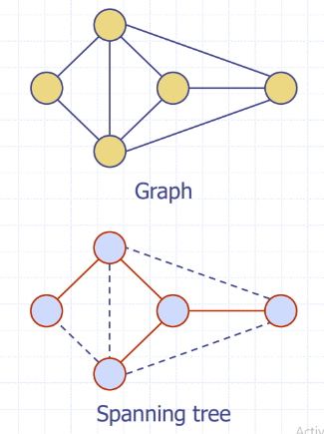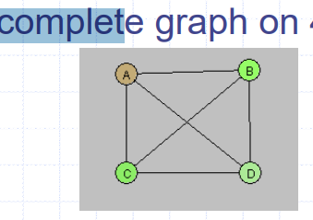

* A spanning tree connects all vertices of a graph without any cycles. A spanning forest is a subgraph in which each connected component is a spanning tree of the vertices in that component.

1. Depth-First Search

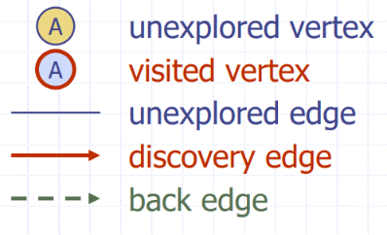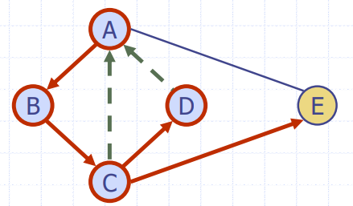

* Algorithm:

A DFS traversal of a graph G

◼ Visits all the vertices and edges of G

◼ Determines whether G is connected

◼ Computes the connected components of G

◼ Computes a spanning forest of G

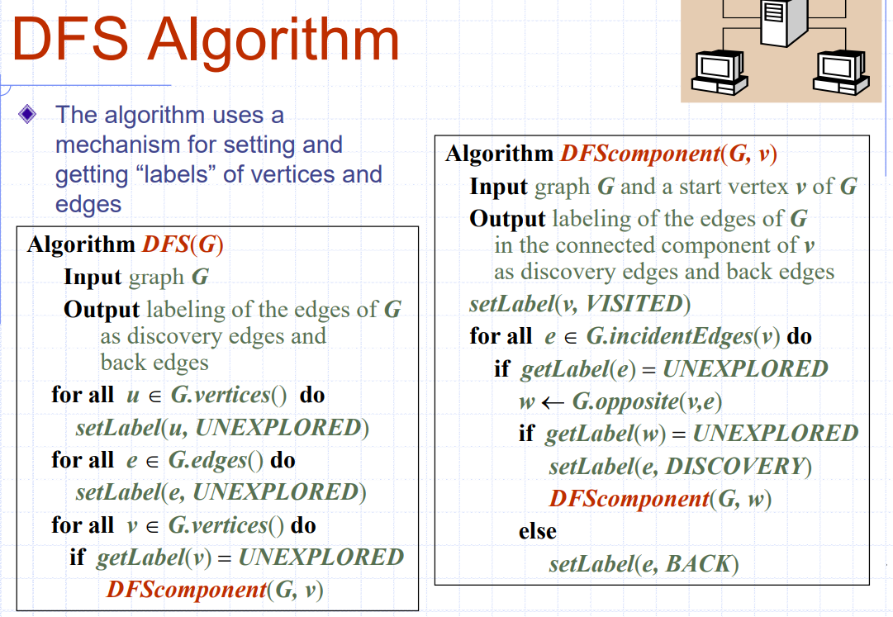

* Finding a Path using DFS

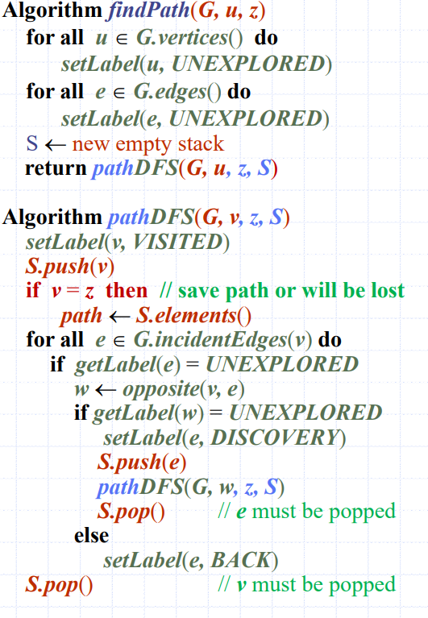

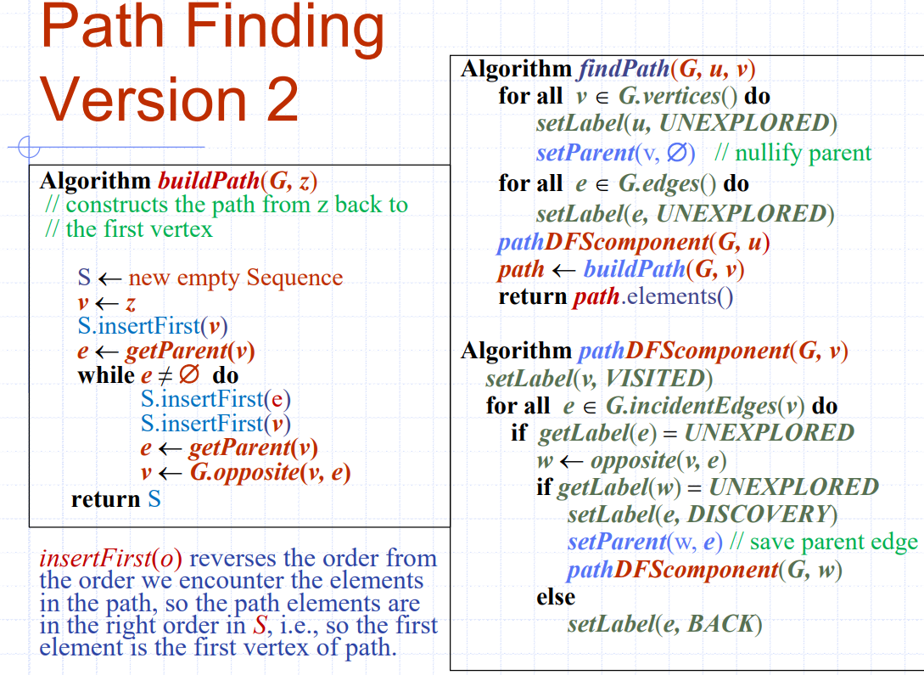

* Cycle Finding

We can use the DFS algorithm to find a simple cycle

We use a stack S to keep track of the path between the start vertex and the current vertex

